Drawer in Flutter

Aim: To Demonstrate Implementation of Drawer in Flutter

Code:
import 'package:flutter/material.dart';

void main() {
runApp(const MyApp());
}

class MyApp extends StatelessWidget {
const MyApp({super.key});

@override
Widget build(BuildContext context) {
return MaterialApp(
debugShowCheckedModeBanner: false,
home: const HomeScreen(),
);
}
}

class HomeScreen extends StatelessWidget {
const HomeScreen({super.key});

@override
Widget build(BuildContext context) {
return Scaffold(
appBar: AppBar(
title: const Text("Travel App"),
),

// ------------------ DRAWER HERE ------------------
drawer: const TravelAppDrawer(),

body: const Center(
child: Text(
"Welcome to the Travel App!",
style: TextStyle(fontSize: 22),
),
),
);
}
}

class TravelAppDrawer extends StatelessWidget {
const TravelAppDrawer({super.key});

@override
Widget build(BuildContext context) {
return Drawer(
child: ListView(
padding: EdgeInsets.zero,
children: [

// ------------------ Drawer Header ------------------
DrawerHeader(
decoration: const BoxDecoration(
image: DecorationImage(
image: AssetImage("assets/images/travel_bg.jpg"), // <-- You can replace
fit: BoxFit.cover,
),
),
child: Column(
crossAxisAlignment: CrossAxisAlignment.start,
children: [
const CircleAvatar(
radius: 32,
backgroundImage: AssetImage("assets/images/profile.jpg"), // <-- Replace
),
const SizedBox(height: 12),
const Text(
"Welcome, Traveler!",
style: TextStyle(
color: Colors.white,
fontSize: 20,
fontWeight: FontWeight.bold,
),
),
],
),
),

// ------------------ Drawer Items ------------------
ListTile(
leading: const Icon(Icons.flight_takeoff),
title: const Text("Discover Trips"),
onTap: () {},
),
ListTile(
leading: const Icon(Icons.map),
title: const Text("Explore Map"),
onTap: () {},
),
ListTile(
leading: const Icon(Icons.shopping_bag),
title: const Text("Bookings"),
onTap: () {},
),

const Divider(),

ListTile(
leading: const Icon(Icons.favorite),
title: const Text("Saved Places"),
onTap: () {},
),
ListTile(
leading: const Icon(Icons.card_travel),
title: const Text("Travel Packages"),
onTap: () {},
),
ListTile(
leading: const Icon(Icons.support_agent),
title: const Text("Support"),
onTap: () {},
),

const Divider(),

ListTile(
leading: const Icon(Icons.settings),
title: const Text("Settings"),
onTap: () {},
),
ListTile(
leading: const Icon(Icons.logout),
title: const Text("Logout"),
onTap: () {},
),
],
),
);
}
}

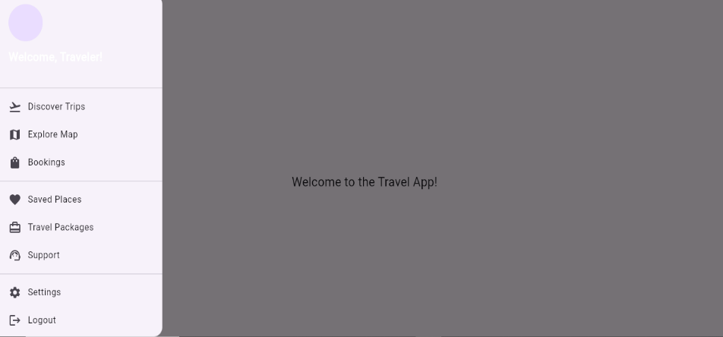
Output:

Concepts:
Widgets
Travel(Stateless Widget)

